LÊ HỮU HOÀN  
Home work 10/11/2023  
  
LẬP TRÌNH C# 3

|  |
| --- |
| <Window x:Class="Learn_WDF.MainWindow"  xmlns="http://schemas.microsoft.com/winfx/2006/xaml/presentation"  xmlns:x="http://schemas.microsoft.com/winfx/2006/xaml"  xmlns:d="http://schemas.microsoft.com/expression/blend/2008"  xmlns:mc="http://schemas.openxmlformats.org/markup-compatibility/2006"  xmlns:local="clr-namespace:Learn_WDF"  mc:Ignorable="d"  Title="MainWindow" Height="450" Width="800">  <Grid>  <TextBlock HorizontalAlignment="Center" Margin="0,176,0,0" FontWeight="Bold" TextWrapping="Wrap" Text="Hello world!" FontSize="32px" VerticalAlignment="Top" Height="54" Width="328"/>  <Button HorizontalAlignment="Center" Name="Button" Height="60" Width="180" Margin="0,120,0,0" FontSize="32" >Click here</Button>  </Grid>  </Window> |

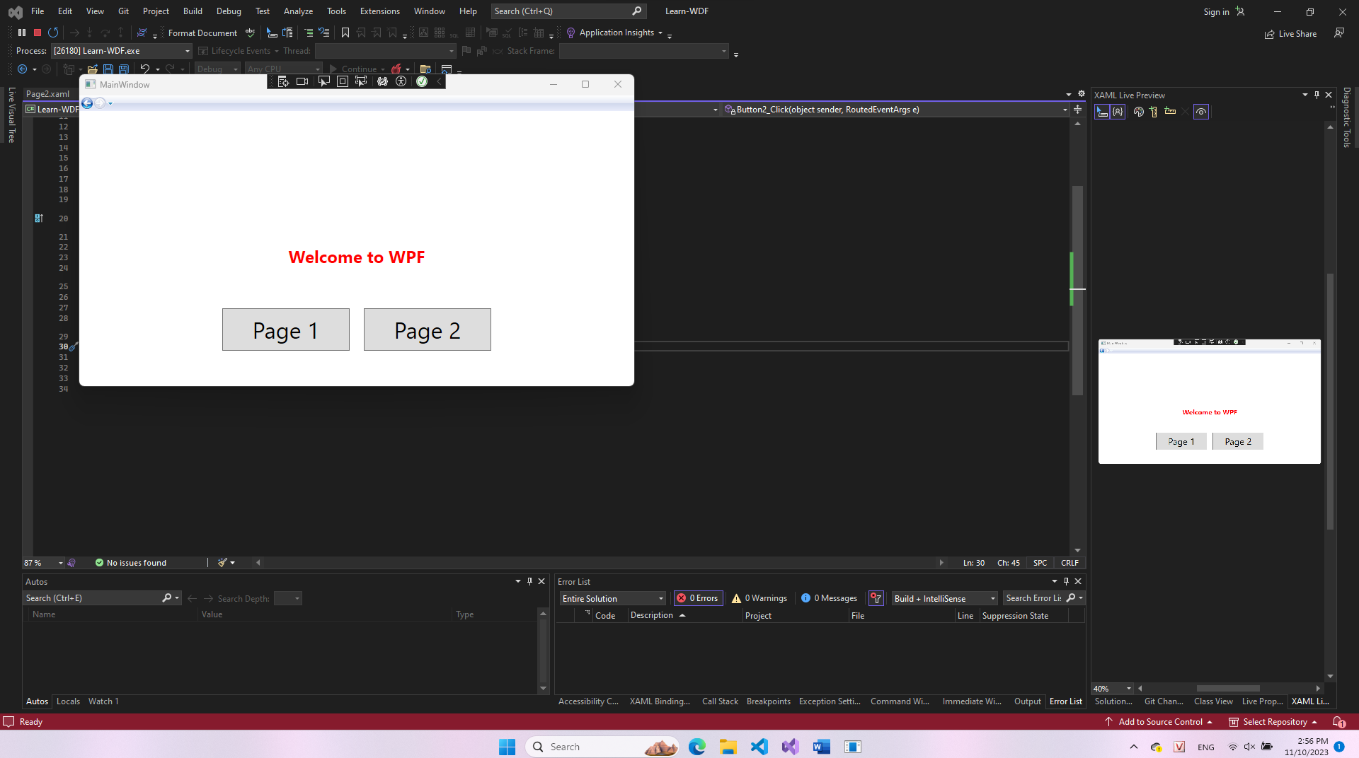

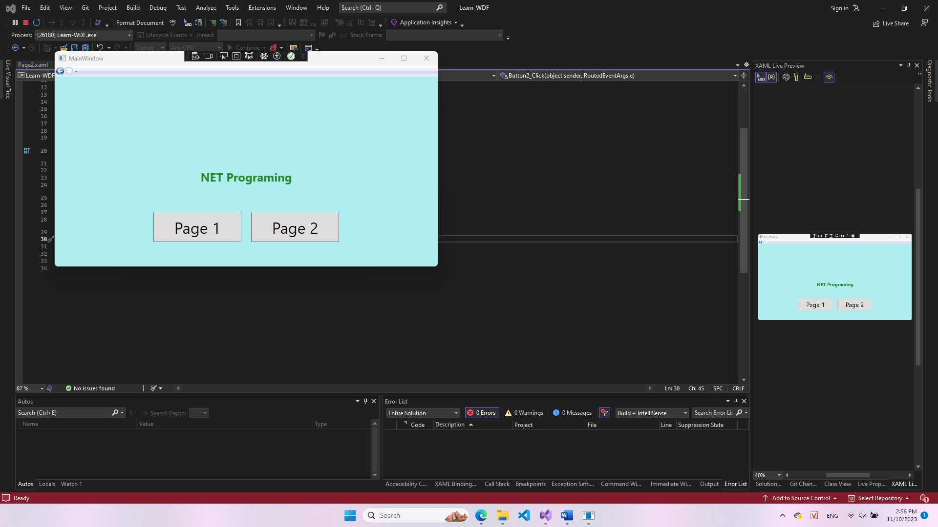

|  |
| --- |
| using System;  using System.Collections.Generic;  using System.Linq;  using System.Text;  using System.Threading.Tasks;  using System.Windows;  using System.Windows.Controls;  using System.Windows.Data;  using System.Windows.Documents;  using System.Windows.Input;  using System.Windows.Media;  using System.Windows.Media.Imaging;  using System.Windows.Navigation;  using System.Windows.Shapes;  namespace Learn_WDF {  /// <summary>  /// Interaction logic for MainWindow.xaml  /// </summary>  public partial class MainWindow : Window {  public MainWindow() {  InitializeComponent();  }  private void Button1_Click(object sender, RoutedEventArgs e) {  frameMain.Content = new Page1();  }  private void Button2_Click(object sender, RoutedEventArgs e) {  frameMain.Content = new Page2();  }  }  } |

|  |
| --- |
| <Page x:Class="Learn_WDF.Page1"  xmlns="http://schemas.microsoft.com/winfx/2006/xaml/presentation"  xmlns:x="http://schemas.microsoft.com/winfx/2006/xaml"  xmlns:mc="http://schemas.openxmlformats.org/markup-compatibility/2006"  xmlns:d="http://schemas.microsoft.com/expression/blend/2008"  xmlns:local="clr-namespace:Learn_WDF"  mc:Ignorable="d"  d:DesignHeight="450" d:DesignWidth="800"  Title="Page1">  <Grid>  <TextBlock HorizontalAlignment="Center" Margin="0,189,0,0" FontSize="24" TextWrapping="Wrap" Text="Welcome to WPF" FontWeight="Bold" Foreground="Red" VerticalAlignment="Top"/>  </Grid>  </Page> |

|  |
| --- |
| <Page x:Class="Learn_WDF.Page2"  xmlns="http://schemas.microsoft.com/winfx/2006/xaml/presentation"  xmlns:x="http://schemas.microsoft.com/winfx/2006/xaml"  xmlns:mc="http://schemas.openxmlformats.org/markup-compatibility/2006"  xmlns:d="http://schemas.microsoft.com/expression/blend/2008"  xmlns:local="clr-namespace:Learn_WDF"  mc:Ignorable="d"  d:DesignHeight="450" d:DesignWidth="800"  Title="Page2">  <Grid Background="PaleTurquoise">  <TextBlock HorizontalAlignment="Center" Margin="0,189,0,0" FontSize="24" TextWrapping="Wrap" Text="NET Programing" FontWeight="Bold" Foreground="ForestGreen" VerticalAlignment="Top"/>  </Grid>  </Page> |

|  |
| --- |
| <Window x:Class="Learn_WDF.MainWindow"  xmlns="http://schemas.microsoft.com/winfx/2006/xaml/presentation"  xmlns:x="http://schemas.microsoft.com/winfx/2006/xaml"  xmlns:d="http://schemas.microsoft.com/expression/blend/2008"  xmlns:mc="http://schemas.openxmlformats.org/markup-compatibility/2006"  xmlns:local="clr-namespace:Learn_WDF"  mc:Ignorable="d"  Title="MainWindow" Height="450" Width="800">  <Grid>  <Frame x:Name="frameMain" VerticalAlignment="Stretch" NavigationUIVisibility="Visible"/>  <Button HorizontalAlignment="Center" Name="Button1" Height="60" Width="180" Margin="-200,250,0,0" FontSize="32" Click="Button1_Click" >Page 1</Button>  <Button HorizontalAlignment="Center" Name="Button2" Height="60" Width="180" Margin="200,250,0,0" FontSize="32" Click="Button2_Click" >Page 2</Button>  </Grid>  </Window> |

|  |
| --- |
| <Window x:Class="LayoutDemo.MainWindow"  xmlns="http://schemas.microsoft.com/winfx/2006/xaml/presentation"  xmlns:x="http://schemas.microsoft.com/winfx/2006/xaml"  xmlns:d="http://schemas.microsoft.com/expression/blend/2008"  xmlns:mc="http://schemas.openxmlformats.org/markup-compatibility/2006"  xmlns:local="clr-namespace:LayoutDemo"  mc:Ignorable="d"  Title="MainWindow" Height="450" Width="800">  <Grid>  <WrapPanel Background="LightBlue" Orientation="Vertical">  <Label Content="CarName" Height="32" Width="740"/>  <TextBox Height="47" Name="txtCarName" TextWrapping="Wrap" Text="CarName" Width="754"/>  <Label Content="Color" Height="32" Width="740"/>  <TextBox Height="47" Name="txtColor" TextWrapping="Wrap" Text="Color" Width="754"/>  <Label Content="Brand" Height="32" Width="740"/>  <TextBox Height="47" Name="txtBrand" TextWrapping="Wrap" Text="Brand" Width="754"/>  <Button Content="Display" RenderTransformOrigin="0.519,2.509" Height="39" Margin="10,10,10,10" Click="Button_Click"/>  </WrapPanel>  </Grid>  </Window> |

|  |
| --- |
| using System;  using System.Collections.Generic;  using System.Linq;  using System.Text;  using System.Threading.Tasks;  using System.Windows;  using System.Windows.Controls;  using System.Windows.Data;  using System.Windows.Documents;  using System.Windows.Input;  using System.Windows.Media;  using System.Windows.Media.Imaging;  using System.Windows.Navigation;  using System.Windows.Shapes;  namespace LayoutDemo {  /// <summary>  /// Interaction logic for MainWindow.xaml  /// </summary>  public partial class MainWindow : Window {  public MainWindow() {  InitializeComponent();  }  private void Button_Click(object sender, RoutedEventArgs e) {  MessageBox.Show($"Name:{txtCarName.Text} , color:{txtColor.Text}, Brand:{txtBrand.Text}");  }  }  } |

|  |
| --- |
| <Window x:Class="LayoutDemo.Window1"  xmlns="http://schemas.microsoft.com/winfx/2006/xaml/presentation"  xmlns:x="http://schemas.microsoft.com/winfx/2006/xaml"  xmlns:d="http://schemas.microsoft.com/expression/blend/2008"  xmlns:mc="http://schemas.openxmlformats.org/markup-compatibility/2006"  xmlns:local="clr-namespace:LayoutDemo"  mc:Ignorable="d"  Title="Window1" Height="450" Width="800">  <Grid>  <StackPanel Background="LightBlue" Orientation="Vertical">  <Label Content="CarName" Height="32" Width="740"/>  <TextBox Height="47" Name="txtCarName" TextWrapping="Wrap" Text="CarName" Width="754"/>  <Label Content="Color" Height="32" Width="740"/>  <TextBox Height="47" Name="txtColor" TextWrapping="Wrap" Text="Color" Width="754"/>  <Label Content="Brand" Height="32" Width="740"/>  <TextBox Height="47" Name="txtBrand" TextWrapping="Wrap" Text="Brand" Width="754"/>  <Button Content="Display" RenderTransformOrigin="0.519,2.509" Height="39" Margin="10,10,10,10" Click="Button_Click"/>  </StackPanel>  </Grid>  </Window> |

|  |
| --- |
| <Window x:Class="LayoutDemo.Window2"  xmlns="http://schemas.microsoft.com/winfx/2006/xaml/presentation"  xmlns:x="http://schemas.microsoft.com/winfx/2006/xaml"  xmlns:d="http://schemas.microsoft.com/expression/blend/2008"  xmlns:mc="http://schemas.openxmlformats.org/markup-compatibility/2006"  xmlns:local="clr-namespace:LayoutDemo"  mc:Ignorable="d"  Title="Window2" Height="450" Width="800">  <Grid>  <Grid.ColumnDefinitions>  <ColumnDefinition Width="Auto"/>  <ColumnDefinition Width="300"/>  </Grid.ColumnDefinitions>  <Grid.RowDefinitions>  <RowDefinition Height="Auto"/>  <RowDefinition Height="Auto"/>  <RowDefinition Height="*"/>  <RowDefinition Height="28"/>  </Grid.RowDefinitions>  <Label Grid.Row="0" Grid.Column="0" Content="Name"/>  <Label Grid.Row="1" Grid.Column="0" Content="Email:"/>  <Label Grid.Row="2" Grid.Column="0" Content="Message"/>  <TextBox Grid.Column="1" Grid.Row="0" Margin="3"/>  <TextBox Grid.Row="1" Grid.Column="1" Margin="3"/>  <TextBox Grid.Row="2" Grid.Column="1" Margin="3"/>  <Button Grid.Column="1" Grid.Row="3" HorizontalAlignment="Center" MinWidth="180" Margin="3" Content="Send"/>  </Grid>  </Window> |